**Step1: get the API url and Elements in a variable**

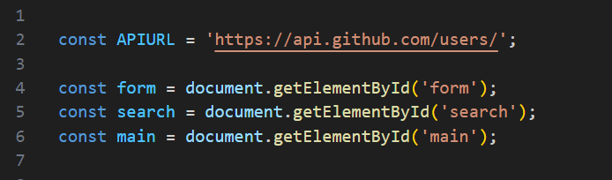

**Step2: Join the Url and Username and call the function with passing value inside parenthesis.**

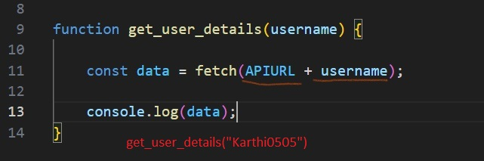

**Step3: async keyword makes the function Asynchronous.  
await keyword waits until the request completes...  
Because the await keyword is present, the asynchronous function is paused until the request completes.**

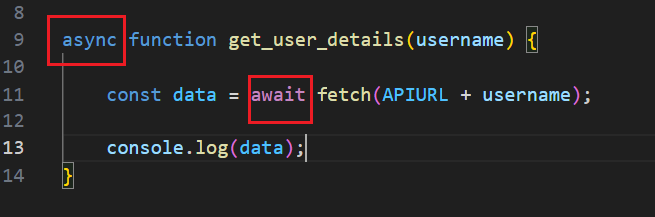

**Step4: .json() of Response interface takes a Response stream and reads it to completion.   
It takes JSON as input and parse it to a JavaScript object**

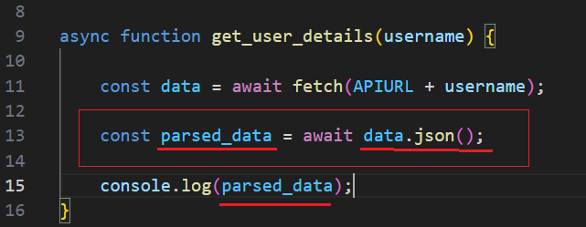

**Step5: Put the HTML and put the variable inside it.  
Store it in a variable**

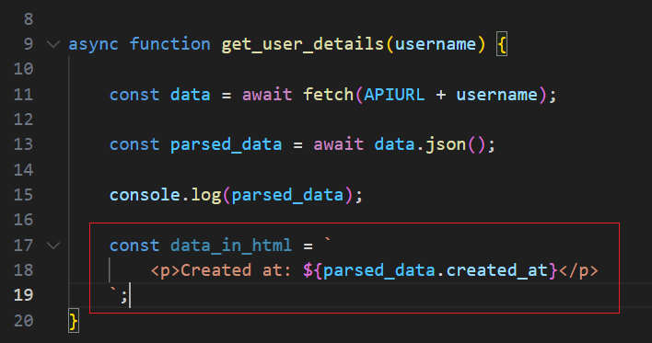

**Step6: put the html inside the <main> element**

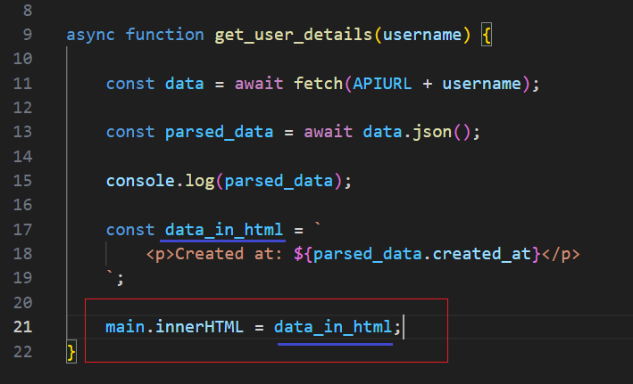

**Step7: Get the input value and pass it inside function call paranthesis**

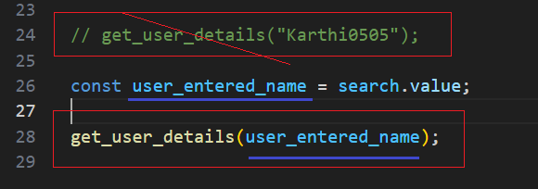

**Step8: Trigger the function call on form submit event**

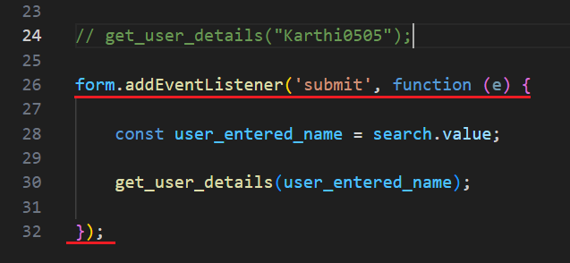

**Step9: Now if you submit the form, it will refresh the browser.  
To avoid this put the e.preventDefault() code**

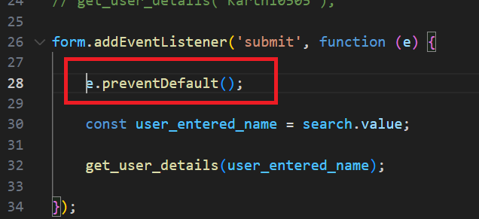

**Step10: Put condition, if there is value entered only it should call the function**

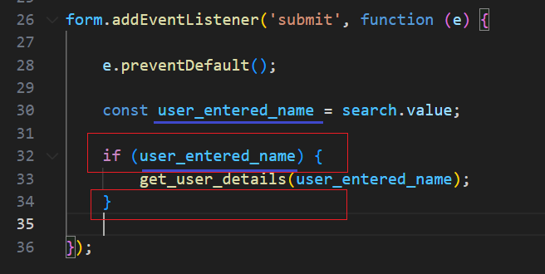

**Step11:**

